What a VPN is
Virtual Private Network (VPN) – is a means to encrypt and secure data to keep safe and add a layer of privacy to protect one's identity. This is a secure way to access the internet. This technology allows one to connect one or more computers to a private network remotely and securely usually via the internet. One can link many different networks and even servers in a safer way. It allows users to surf safely on public Wi-Fi networks at places like shopping malls, hotels, and coffee shops and it allows them to bypass network censorship and original restrictions on content and sites. Virtual Private Networks helps prevent attacks, which is when a cyber-criminal intercepts legitimate communication, by assuming the role of the intermediary and simulating a normal connection.
How a VPNs work
We can represent how a connection is generated by using a pathway with a start and the end and with different control points through which data packets travel. When using a VPN, end encryption, and authentication layer are applied to the pathway that data packets travel through in order to protect the network traffic with a data packet travel, this technique is known as VPN Tunnel Link which creates a secure communication channel within a network of computers. Therefore in this tunnel, this communication channel, data that is traveling along the pathway is protected. All the intermediate nodes that are involved in the communication will interact with the packet. But it is only at the end of the communication that the information is revealed and decrypted for use. The authentication layer will verify the identity of the users and restrict access accordingly. Those not authorized will not be able to get in.
Virtual Private Networks work by routing users’ devices internet connection through the user’s picked VPN’s private server or private server of their own choice, instead of Internet Service Providers with the goal that when information is transmitted to the internet, it originates from the VPN instead of the PC. It conceals the IP address and securing users' identities. If data is intercepted, one will not be able to read it until it reaches its destination.
VPN technologies that could be used to secure a site-to-site connection
There are different and various technologies that are used to ensure a safe secure connections. The main protocols include:
- IP security (IPsec)
- Point-to-Point Tunneling Protocol (PPTP)
- Layer 2 Tunneling Protocol (L2TP)
IP security (IPsec)
This is a widely used VPN protocol which gives direct access to the network that is central to all, to the remote computer. It, therefore, gives clients the resources they require or need, at any place they are found.
In order to access the VPN, it requires the users to have third-party software because it is not executed through browsers. It has a lot of processes as it requires to be purchased by clients, install, update, and sometimes pay for maintenance. Therefore making it complicated to execute and configure. This also can make the users who are not experts to end up with an IPSec connection which may turn to be not safe.
Point-to-Point Tunneling Protocol (PPTP)
This is an older version of the technology used for implementing Virtual Private Network. It is less expensive and very simple and easy to configure than any other protocols, on the grounds that it does not need the Public Key infrastructure to execute. It has a fast speed due to its low level of encryption. Point-to-Point Tunneling Protocol is not secure enough because it uses 128-bit encryption to secure information.

Layer 2 Tunneling Protocol (L2TP)
This is a tunneling methodology which allows users remotely to have access over the common network. It is easy to set up and configure L2TP on any device because many platforms that execute this protocol have native support for this protocol.
Layer 2 Tunneling Protocol has better security than PPTP because it is not vulnerable to security issues.
L2TP uses 256-bit encryption to secure information hence consumes more CPU resources compared to PPTP. This makes it to have low-speed connections.

The difference between symmetric and asymmetric encryption

Symmetric Encryption

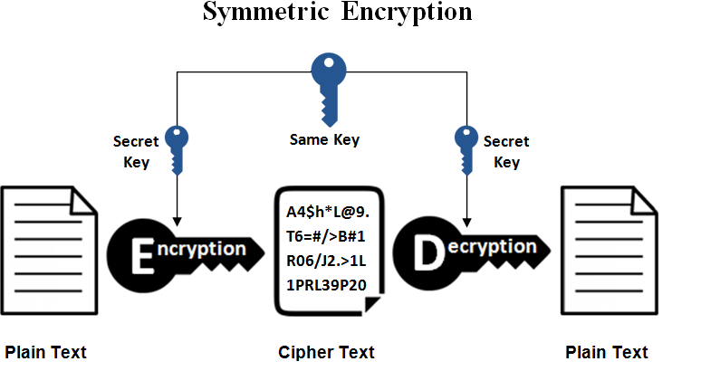
Symmetric encryption is a technique that entails only one unknown secret key, which can be alphanumeric, to cipher and decipher data. The one who is sending the message and the one receiving must know that secret key in order to encrypt and decrypt every message.
Examples of symmetric encryption are RC4, RC5, DES, RC6, and Blowfish.
Asymmetric Encryption
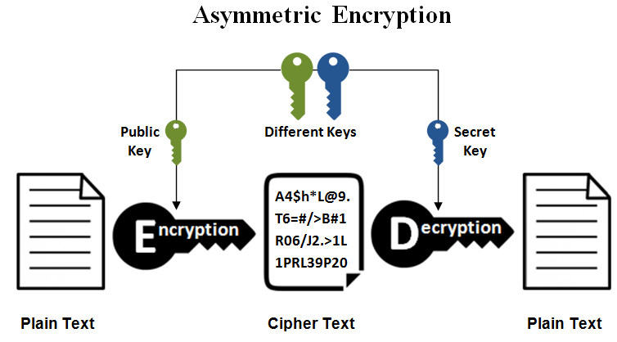
Asymmetric encryption is a new technique compared to symmetric encryption. This type of encryption uses two keys to decode a plain text. These keys are shared over the internet. It guarantees that malevolent people on the internet don't misuse the exchanged keys. Asymmetric encryption uses two keys for security purposes since anybody who have these keys can decode the message and have access to it.
This encryption uses a set of public key and private keys to encode and decode messages when communicating therefore ensuring the security of information transmitted during communication.
Examples of the Asymmetric encryption algorithm include DSA, RSA, PKCS, etc.

Implement an IPSec Site-to-Site VPN between the main site edge router and the server farm edge router. Describe the configuration and testing of the Site-to-Site VPN.
First I configure IPsec parameters on the first router – hostname R1
Configure the ACL 110, which is the Access-list 110, to identify the traffic from the LAN on the first router, R1, to the LAN on the Second router, R3. This traffic will trigger the IPSec VPN to be implemented.
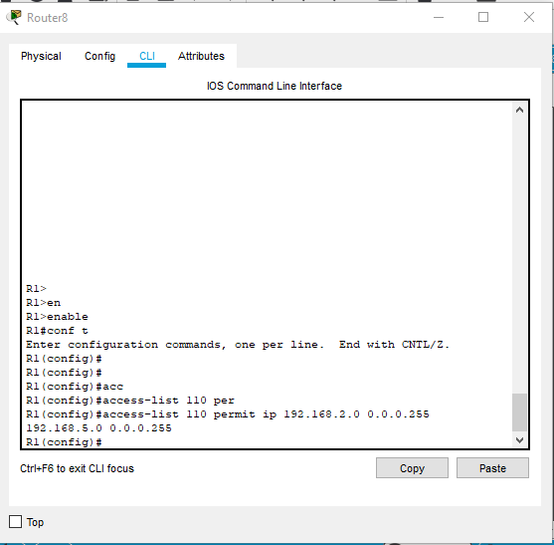

Then I configured crypto iaskmp policy 10 on router R1 and the share crypto key VPNpa55

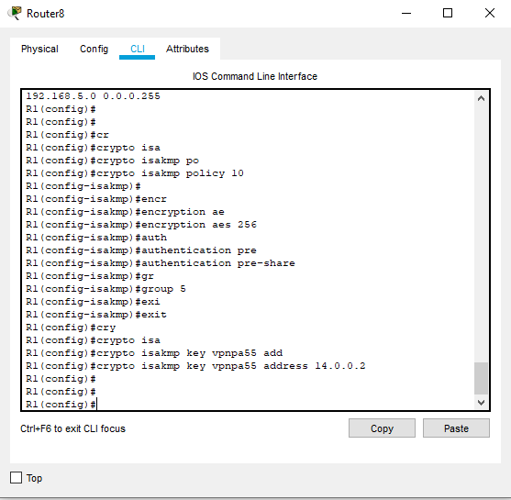

After here, I created the transform-set in VPN-SET using the esp-sha-hman mark

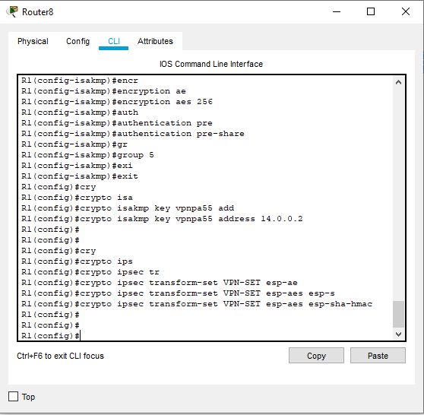

I created a crypto map name “VPN-MAP”. I set peer as router R3 interface then set “transform-set” as I configured earlier before and match address 110.

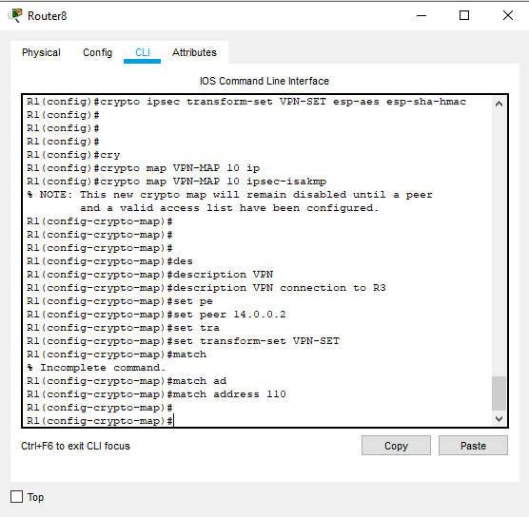

The last thing I did on router R1 is to find the VPN-MAP crypto map to the outgoing serial s0/0/0 interface of router R1.

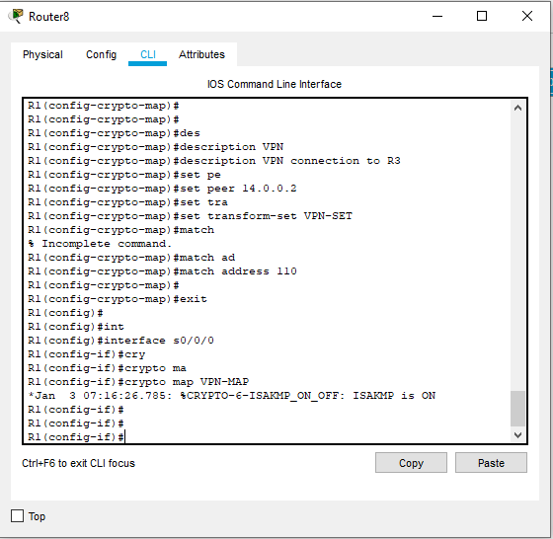

After configuring router R1, I do the same thing on the second router, the hostname is R3, to set the IPSec parameters on it.

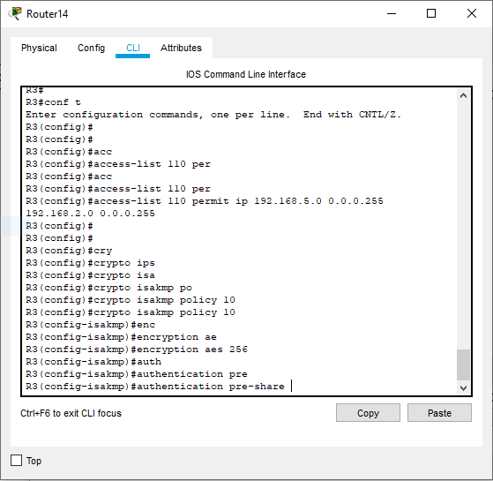

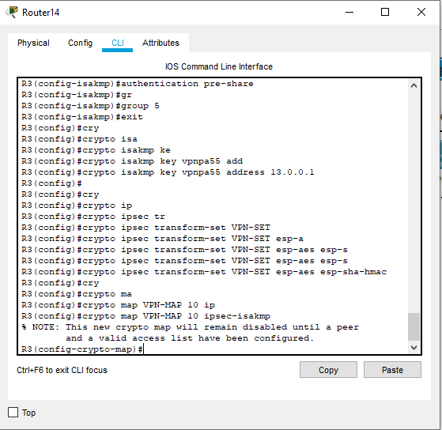

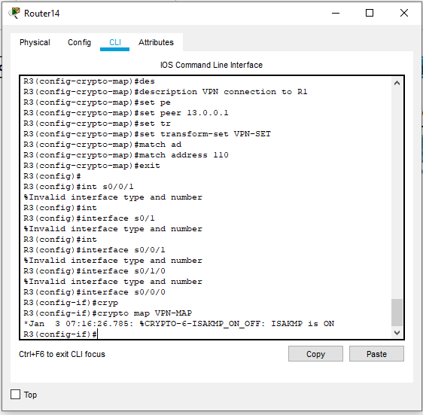

The IPSec site-to-site encryption of data packet is complete at this stage and data communicated should be secure and encrypted.

